IoT Smart Walker for Elderly Assistance System

Project / Course:
Media Management
Student Name:
Nouman

Group Members:
Hassan
Haris
Nouman
Zain

Date:
January 2025

Introduction
The global elderly population is expanding rapidly, with the World Health Organization predicting 2.1 billion people aged 60 or older by 2050. These demographic faces significant health risks, particularly cardiovascular and respiratory complications that may develop gradually and often without visible symptoms. Walker-dependent elderly individuals are especially vulnerable to irregular heart rhythms, dangerously low blood oxygen levels (hypoxemia), and sudden health declines. These risks often culminate in emergencies such as falls, fainting, or acute cardiac events, which conventional residential monitoring solutions fail to detect effectively.
Standard walkers provide mobility support but no health monitoring, leaving a gap in early warning and preventative care. Hospital-grade monitoring or 24/7 caregiver supervision is impractical for most households due to cost and logistical constraints. Additionally, walker users often become increasingly sedentary, exacerbating physical deterioration and fall risk.
The IoT Smart Walker aims to address these challenges by integrating continuous vital sign tracking into a standard walker. It monitors three key physiological parameters: heart rate (detecting arrhythmias or stress), blood oxygen saturation (identifying hypoxemia or respiratory issues), and body temperature (alerting to fever or infection). By providing real time health assessment during routine mobility, the system enables early detection of problems, supports independent living, and enhances safety.

Technical Solution and Architecture

System Architecture
The Smart Walker consists of three architectural layers: hardware interface, signal processing, and application/integration. A Raspberry Pi 3 serves as the central computing platform, connecting to sensors via I2C communication. This modular architecture allows parallel development and simplifies integration of new sensors or features in the future.

Hardware Interface
Vital signs are captured using a MAX30102 sensor for heart rate and SpO₂ and a DS18B20 for body temperature. The MAX30102 operates using photoplethysmography: red (660 nm) and infrared (880 nm) light penetrate tissue to detect changes in blood volume. Data is stored in a 32-sample circular FIFO buffer, with mechanisms to track buffer read/write positions to ensure all samples are captured without overflow or loss.
The DS18B20 temperature sensor provides accurate ±0.5°C readings using digital signals. Both sensors interface with the Raspberry Pi over a 100kHz I2C bus. The architecture ensures reliable data acquisition while allowing other system components to operate concurrently.

Signal Processing
Heart rate and SpO₂ are computed using a 100-sample sliding window, representing approximately four seconds of measurements at an effective 25Hz sampling rate.
Heart rate detection involves:
- Removing the DC offset by subtracting the average signal value from each sample.
- Inverting the infrared signal to convert valleys (heartbeats) into peaks.
- Applying a 4-point moving average filter to smooth motion artifacts caused by walker vibrations.
- Detecting peaks exceeding adaptive thresholds and filtering out peaks too close together (<160 ms apart) to reduce false detections.
- Calculating heart rate as:
Sample Frequency × 60
HR =
Peak Interval
SpO₂ calculation uses the ratio-of-ratios method. For each heartbeat:
1. AC and DC components of red and infrared signals are extracted. 2. The ratio 𝑅 = 𝑅𝑒𝑑^{𝐴𝐶⋅𝐼𝑅𝐷𝐶}is computed.
𝐼𝑅_{𝐴𝐶}⋅𝑅𝑒𝑑𝐷𝐶
3. A calibration formula converts R to oxygen saturation:
𝑆𝑝𝑂₂ = −0.004506𝑅² + 0.30054𝑅 + 94.845

This yields ±2% accuracy for SpO₂ levels between 70–100%.

Application Layer and Threading
Sensor data is collected in a separate thread, allowing non-blocking operation. The system maintains a rolling 100-sample buffer, updating every 10 ms. Heart rate values are smoothed using the last four valid readings to reduce noise, while finger detection ensures that BPM is set to zero if IR and Red LED values drop below 50,000, preventing false alarms.
Threading allows the main program to access real-time BPM and SpO₂ values, handle alerts, and update displays without waiting for sensor operations. Threads are stopped safely using a stop flag to ensure clean shutdowns, avoiding memory leaks and race conditions.

Alert System
The alert mechanism triggers when:
- SpO₂ < 92% (low oxygen), • Heart rate < 50 or > 120 BPM, or
- Temperature > 37.5°C (fever).
Alerts include LED indicators and buzzers to notify the user immediately. Thresholds are adjustable for personalized monitoring.

Results and Analysis
The system achieves continuous, real-time monitoring with ±5 BPM accuracy for heart rate and ±2% for SpO₂ above 90%. Motion artifacts are filtered successfully using the moving average and adaptive peak detection, even during normal walker use. Finger detection prevents incorrect readings when the sensor loses contact.
The threaded design maintains stable 10ms loop timing with CPU usage under 15% and memory around 120MB, leaving room for additional features like advanced motion compensation or enhanced alert logic.
Limitations include sensitivity to rapid heart rate changes or irregular rhythms, which may require more advanced filtering or accelerometer-assisted artifact correction. Temperature monitoring is functional but needs further integration for real-time alerts.

Individual Contribution, Learnings, and Challenges Responsibilities
I designed the application layer and threading architecture, implementing continuous sensor monitoring, rolling buffer management, BPM smoothing, finger detection, and result averaging. I coordinated module integration and developed thread lifecycle management to ensure clean startup and shutdown.

Learnings
I gained experience with Python threading, race conditions, buffer management, and realtime system design. I learned to structure non-blocking applications, synchronize threads safely, handle noisy sensor data, and profile performance-critical code. Working with real sensor data highlighted the importance of robustness and edge-case handling in embedded systems.

Challenges
Thread-safe design was difficult due to race conditions and timing-dependent bugs. Efficient rolling buffer management required careful handling of edge cases, while finger detection thresholds needed extensive testing. Coordinating the timing between sensor acquisition and processing to avoid incomplete or delayed measurements was challenging. Debugging non-deterministic threading issues required systematic logging and iterative testing. Time management was critical, given the iterative nature of debugging and system integration.

Project Implementation Photos
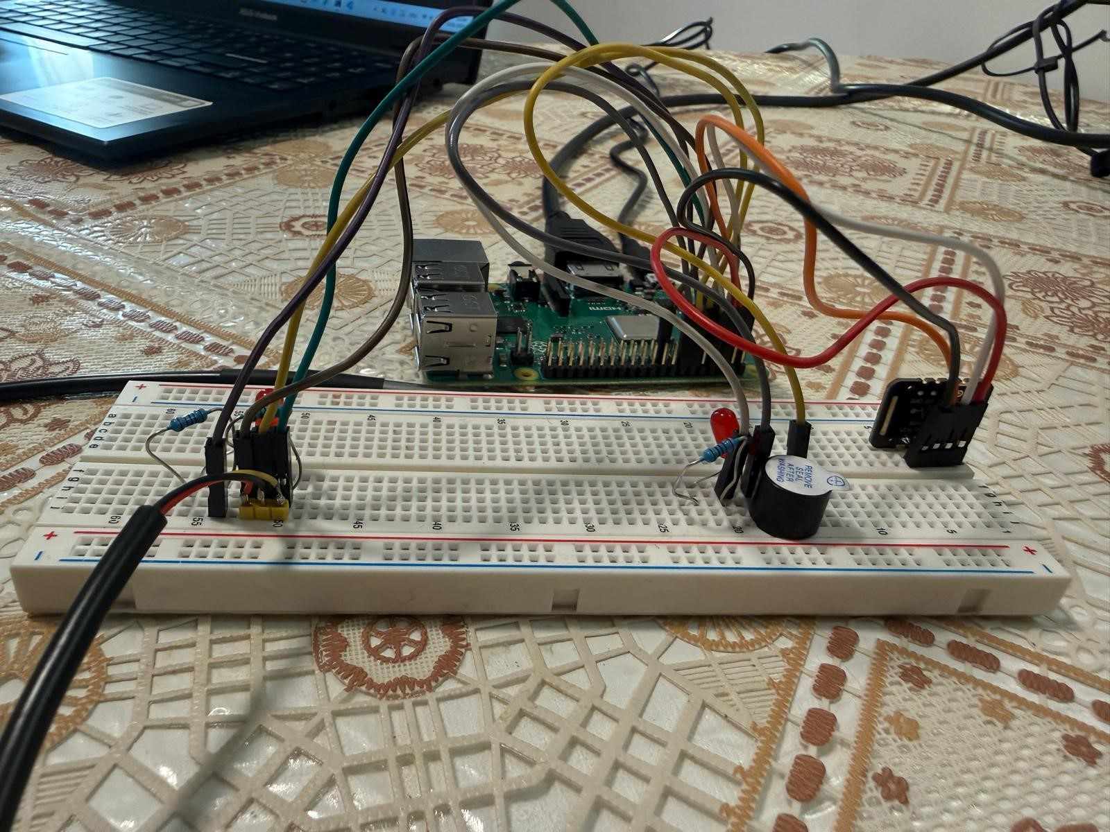
Figure 1: Hardware setup (Raspberry Pi + sensors on breadboard) Figure 2: Wiring overview (side view)
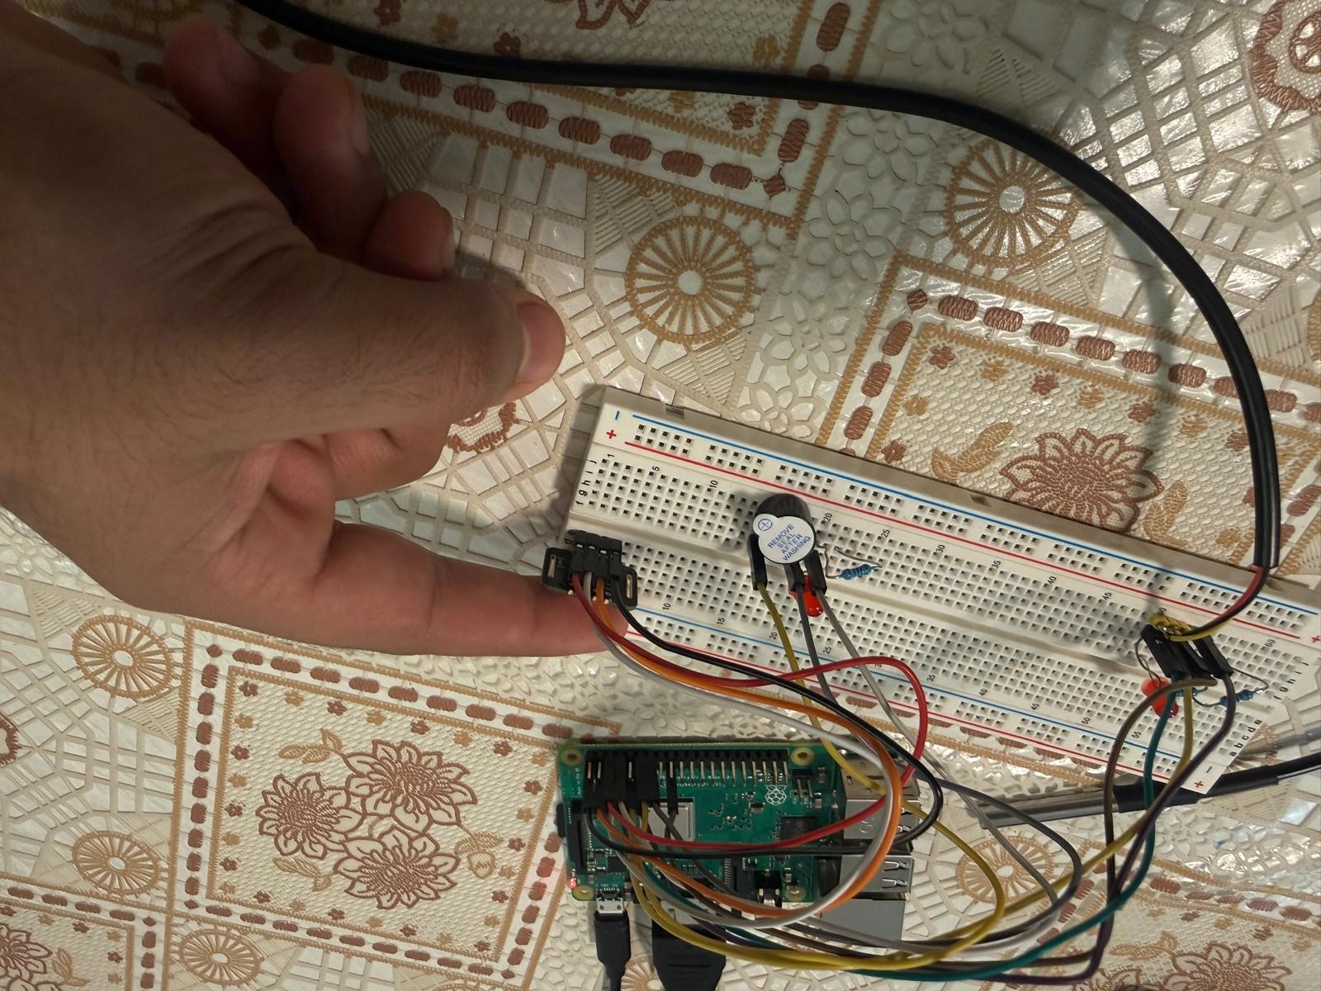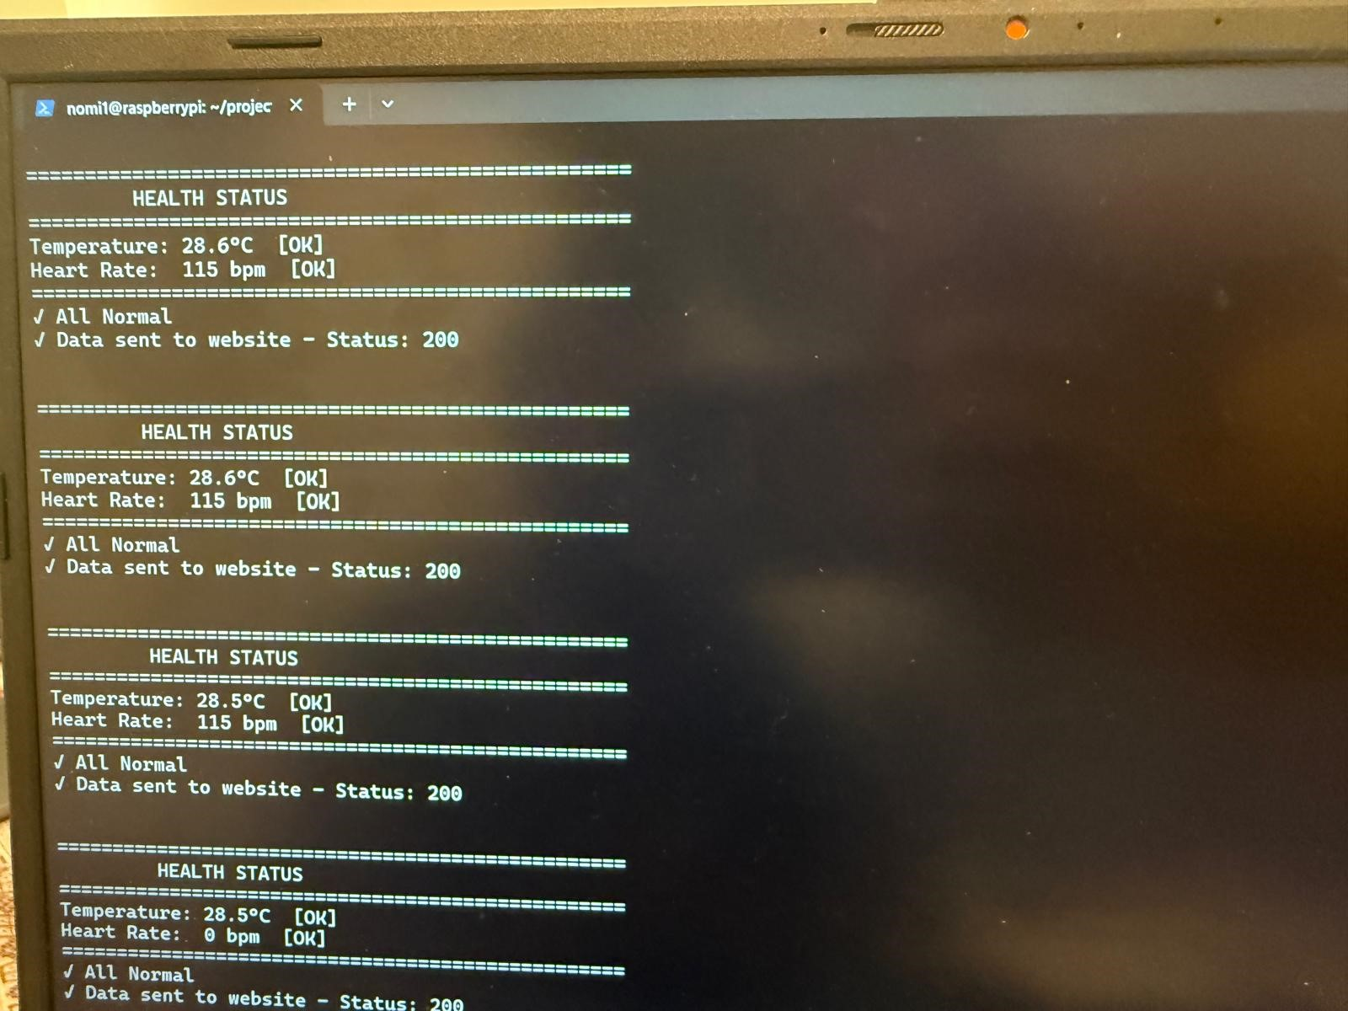
Figure 3: Wiring overview (top view) | Figure 4: Console output (Normal status + HTTP 200)
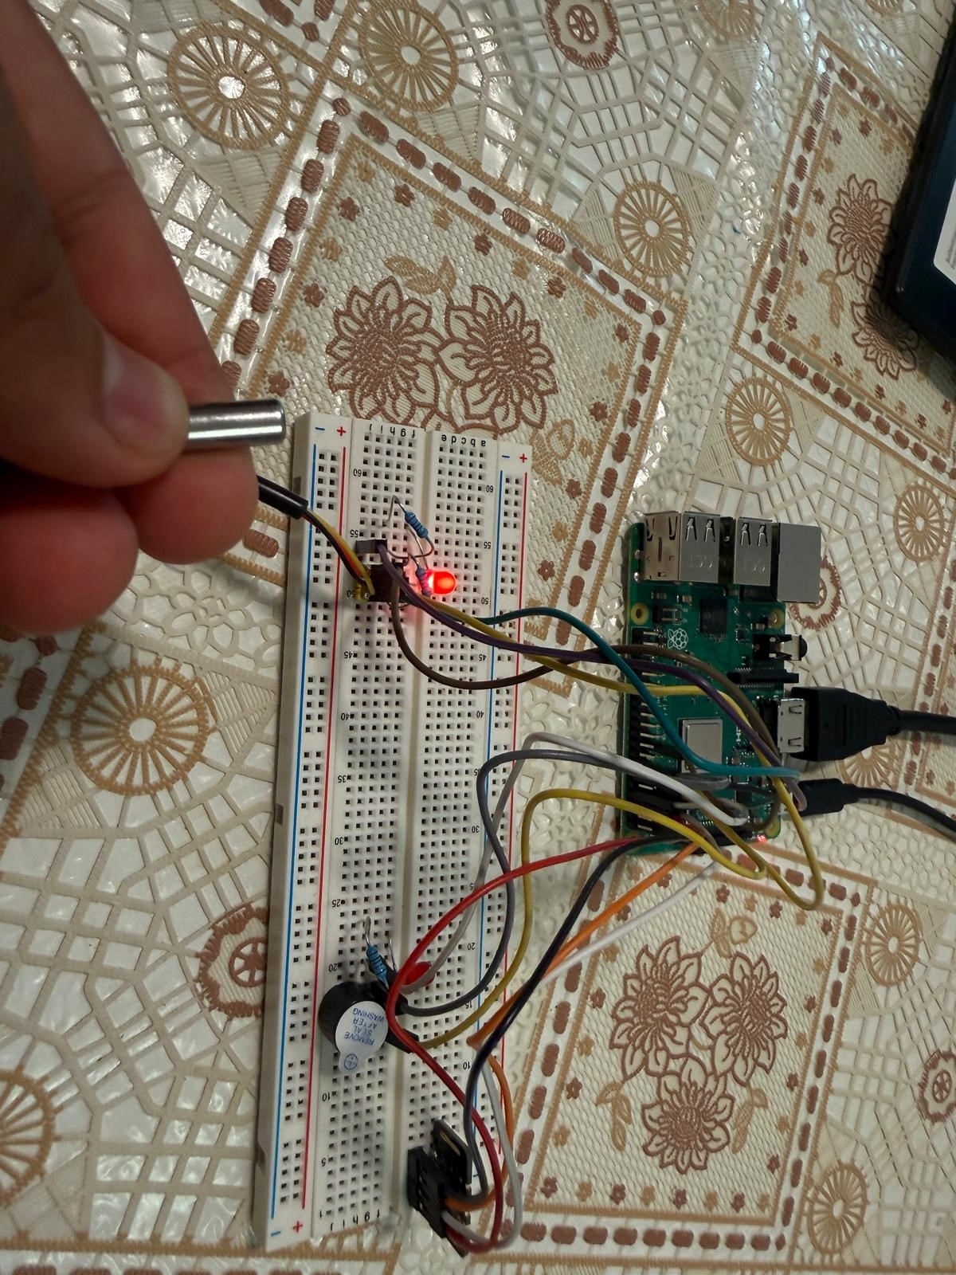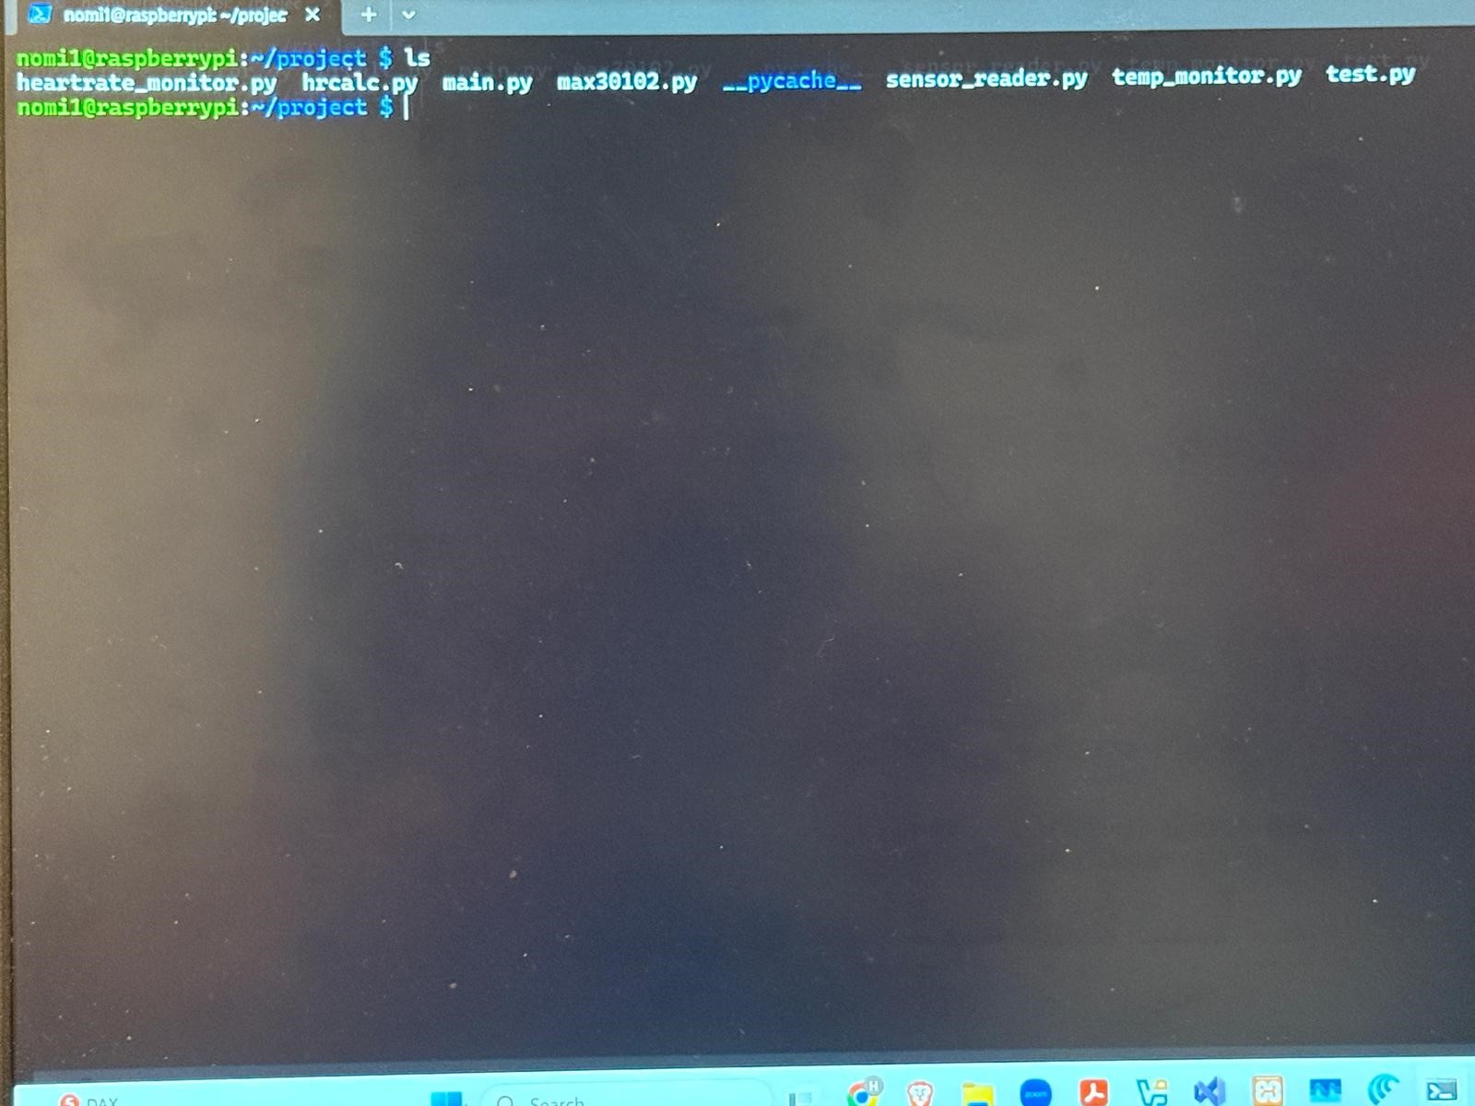
Figure 5: Alarm output (threshold exceeded) Figure 6: Web dashboard (MedHealth Monitor)

